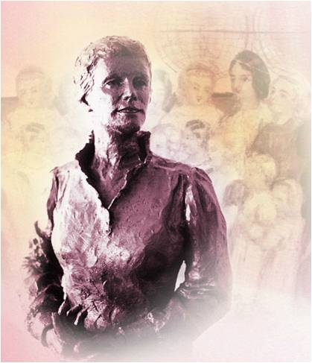

What are some of the features of Catherine’s McAuley as a leader that you find particularly attractive?

Can you select one leadership attribute and how it speaks to the challenge you currently face in your own leadership role?



______________________________________________________________________________________________________________________________________________________________________________________________________________________________________________________________________________________________________________________________________________________________________________________